
Land Information Ontario (LIO) Warehouse
Data Class Name: ANSI
Documentation
Produced by: Information Access and Information Management Policy Unit
Ministry of Natural Resources and Forestry
Date: July 27, 2015

Purpose

This document provides additional information to support the use of geospatial data. The Physical Model Diagram provides a visual representation of the relationships in the data class. The Data Change History lists all the modelling and access changes that have occurred during the lifecycle of the data class. A data description identifying table and field names is available upon request.

Need Assistance?
Please contact LIO Support at lio@ontario.ca or 705-755-1878 if you require help.

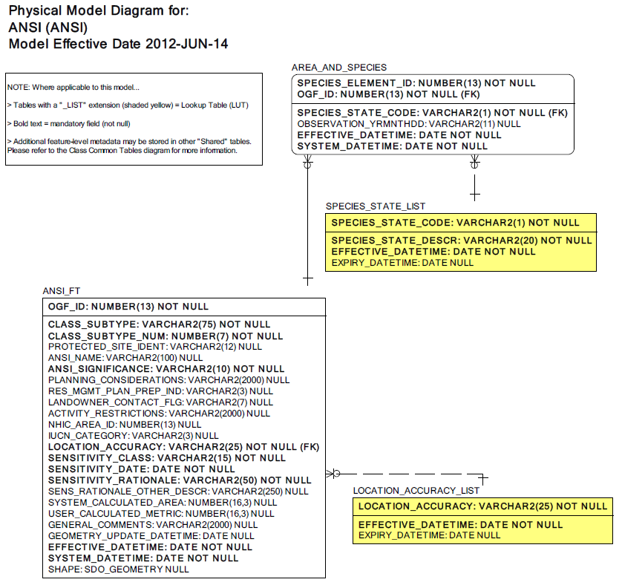

Data Class Change History

Data Class Name: ANSI
Data Class Short Name: ANSI
Date  YYYY-MM-DD | Details of Change
2014-02-13 | Data Access change: ANSI made OpenData
2008 | Updated description of ANSI data class
2008 | GUT: Metadata: ANSI, Life Science. Updated description of GUT
2008 | Updated GUT Description: ANSI, Earth Science
2008 | GUT: Added: Candidate ANSI, Life Science
2008 | GUT Added: Candiate ANSI, Earth Science
2008 | Column dropped: STATUS_TYPE as a user will now indicate the status of the ANSI by its GUT.
2002 | Columns added (OPTIONAL):  - Protected Site Identifer  - NHIC Area ID (identifier)  - IUCN Category
1996 | NEW Data Class for NRVIS 1.0
Data Description
Please refer to the metadata record for the data description.

